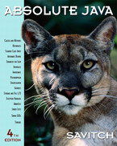 COSC 1320
Name: _________________ Terminal #__

Estimated Hours 1
Actual Hours

TA (Textual Analysis) for UML USE CASE Diagram MODEL
Programming Assignment 2:
(20 points.)
(due date found in the COSC 1320 BB Calendar!)
You must use Microsoft WORD program. Insert the TEMPLATEs for Actors and Use Cases in this Requirements Document.

Please have Step 1, 2, 3, and 4 in this order.
Requirements Analysis: Construct UML USE CASE Diagram MODEL
A1: Customer

GUI PIZZA APPLICATION SWING 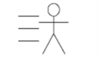

Write a GUI application program, to create a menu for a pizza shop. Use check boxes, radio buttons, and a JButton to allow a customer to make selections and process their order. Use a text area to display the customer’s order and the amount due. A sample menu and a customer’s order is shown in Figure below:
UC4: processOrder
UC1: chooseTopping
UC2: chooseCrust
UC3: chooseSize
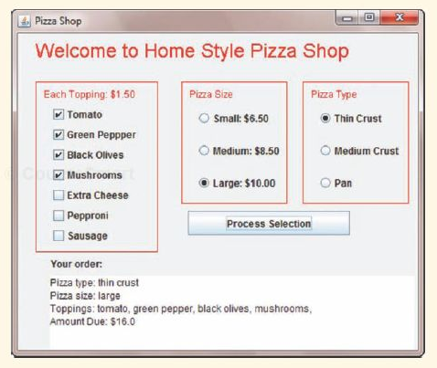

Pizza Shop Controller
UC1: chooseTopping

A1: Customer
UC2: chooseCrust

UC4: processOrder
UC3: chooseSize

UC1: chooseTopping
Customer

chooseTopping
Name:
Successful Completion:
Post-Condition
Actors:
Assumptions:
Pre-Condition:
Description
Alternative:
This is a use case used by Customer to add toppings to his/her pizza.
Customer launches program and is given a GUI to look at.
1. The GUI has a field where Customer can choose to add a topping, if he/she does their bill should be incremented by $1.50 per topping added.

2. When processOrder is enacted the topping cost should be reflected in the output.
Customer launches program and is given a GUI to look at.
1. The GUI button for add topping is pressed and then the user changes their mind and takes the topping away

2. The bill should reflect that the topping does not go on the pizza and should not charge for it.

Customer launches program and adds a topping.
Bill reflects a price of $1.50 per topping added.
Customer requests a topping.

UC2: chooseCrust
Post-Condition
Assumptions:
Pre-Condition:
Alternative:
Customer launches program and is given a GUI to look at.
1. The user does not select a crust.

2. A default selection for crust to the medium crust should take over.

Customer launches program and selects a crust type.
Output reflects the correct crust selection when processOrder is enacted.
Customer requests a topping.
Customer

chooseCrust
Name:
Successful Completion:
Actors:
Description
This is a use case used by Customer select a crust preference.
Customer launches program and is given a GUI to look at.
1. The GUI has a field where Customer can select a crust.

2. The crust should be stored and reflect in their purchase output when processOrder is enacted.

UC3: chooseSize
Customer

chooseSize
Name:
Successful Completion:
Post-Condition
Actors:
Assumptions:
Pre-Condition:
Description
Alternative:
This is a use case used by Customer select a pizza size preference.

Customer launches program and is given a GUI to look at.
1. The GUI has a field where Customer can choose to select a pizza size, if he/she does they should be defaulted to medium size.

2. When processOrder is enacted the size cost should be reflected in the output.
Customer launches program and is given a GUI to look at.
1. The GUI button for large size is pressed and then the user changes their mind and selects a different size.

2. The bill should reflect that the size has changed and the bill should reflect the new size pizza.

Customer launches program and chooses a pizza size.
Bill reflects the price of the respective size of the Customers’ pizza.
Customer selects a pizza size.

UC4: processOrder
Successful Completion:
Post-Condition
Assumptions:
Pre-Condition:
Alternative:
Customer launches program and is given a GUI to look at.
1. The Customer fills out the GUI to reflect the pizza they are requesting and then press the “Process Order” button. Which executes processOrder

2. The user will see a display of their pizza options (size, crust, toppings) as well as a final price for their pizza. (this will be the bill method)
Customer launches program and is given a GUI to look at.
1. The Customer does not make any selections or additions to the pizza.

2. Either a default pizza should be displayed, or an error message requesting that they choose a pizza is displayed.

Customer launches program and fills out choices for a pizza selection, and then presses the “Process Order” button.
Output reflects the respective details of the Customers’ pizza selections, as well as a bill telling them the cost of the pizza.
Customer presses “Process Order” button.
Customer

processOrder
Name:
Actors:
Description
This is a use case used by Customer to signal that they have completed their order.

